Database systems

Lab 5

Hassaan Akbar Cheema

174351

# Lab Task

1. Find average age of students.
2. Find the average age of student in course: ‘Organic Chemistry’.
3. Find eldest student.
4. Find youngest student in ‘Electrical Engineering’ major.
5. Find eldest student in each level.
6. Find average age of students in each level
7. Find the number of distinct class rooms
8. Find the strength of students in each major.
9. Find strength of students in course: ‘Urban Economics’
10. Find the number of courses for student: ‘Karen Scott’.
11. Print the level and the average age of students for that level for all levels except ‘JR’.
12. For each faculty member that has taught classes only in room R128, print the faculty
13. Find the names of all classes and their enrollment strength that have enrollment greater than 2.
14. Find the names and strength of classes taught by ‘Ivana Teach’.
15. Find the number of faculty members that teach to class ‘database Systems’.
16. Find the names, strength of faculty members for each class.
17. Find the age of youngest student in ‘Database Systems’ class.
18. Find the number of classes that occurred in the same room.
19. Find the name and strength of students taught by each faculty member.
20. Find the age of eldest student in the class taught by ‘Ivana Teach’.

ANS 1

Query:

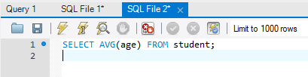

Result:

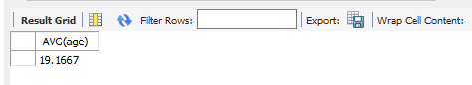

ANS 2

Query:

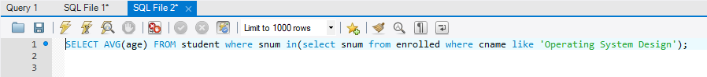

Result:

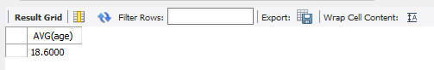

ANS 3

Query:

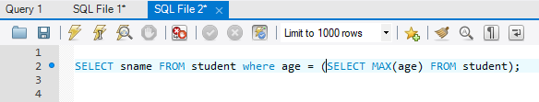

Result:

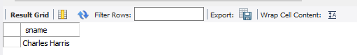

ANS 4

Query:

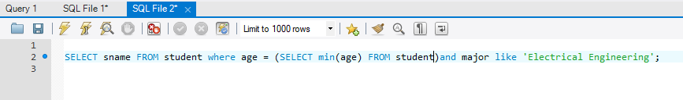

Result:

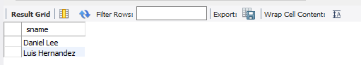

ANS 5

Query:

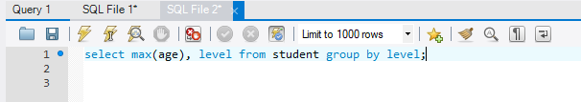

Result:

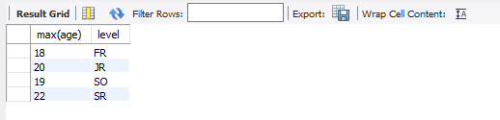

ANS 6

Query:

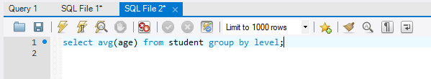

Result:

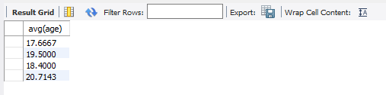

ANS 7

Query:

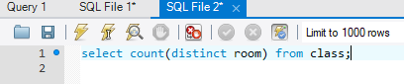

Result:

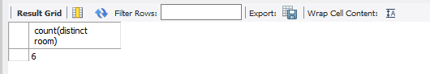

ANS 8

Query:

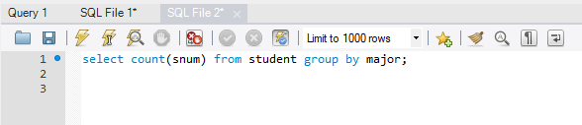

Result:

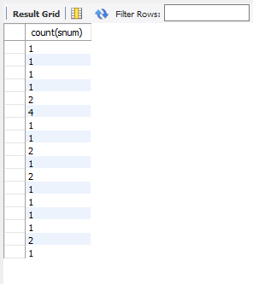

ANS 9

Query:

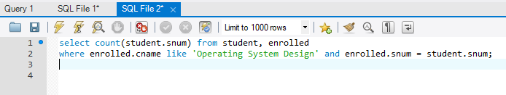

Result:

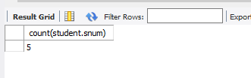

ANS 10

Query:

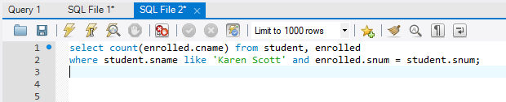

Result:

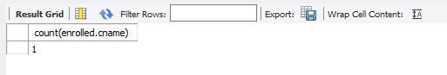

ANS 11

Query:

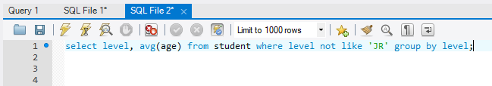

Result:

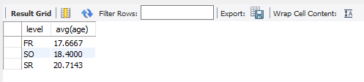

ANS 12

Query:

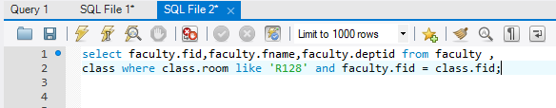

Result:

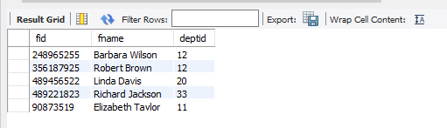

ANS 13

Query:

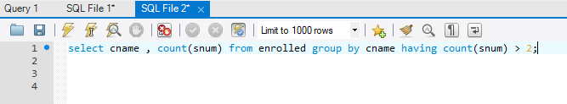

Result:

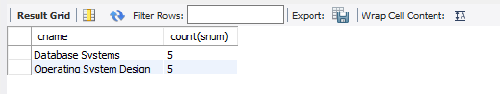

ANS 14

Query:

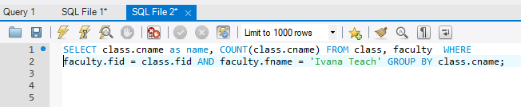

Result:

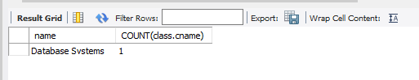

ANS 15

Query:

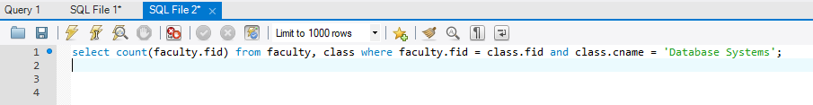

Result:

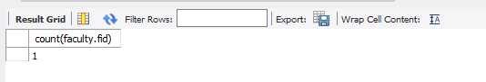

ANS 16

Query:

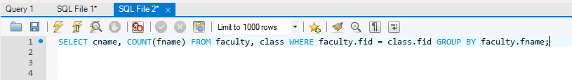

Result:

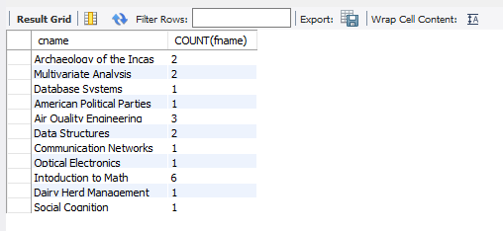

ANS 17

Query:

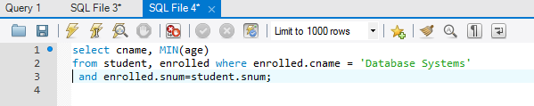

Result:

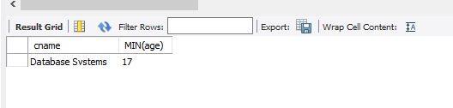

ANS 18

Query:

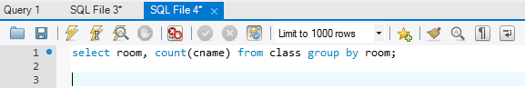

Result:

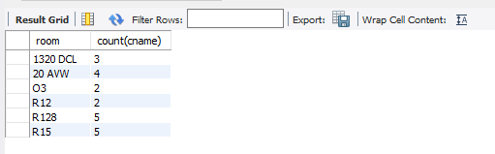

ANS 19

Query:

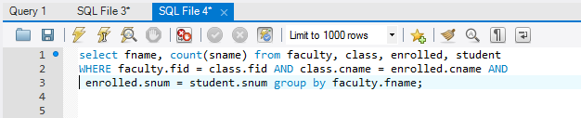

Result:

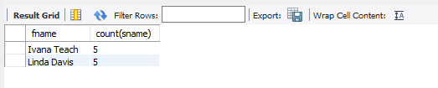

ANS 20

Query:

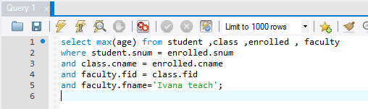

Result:

